1st time terraform setup in Window

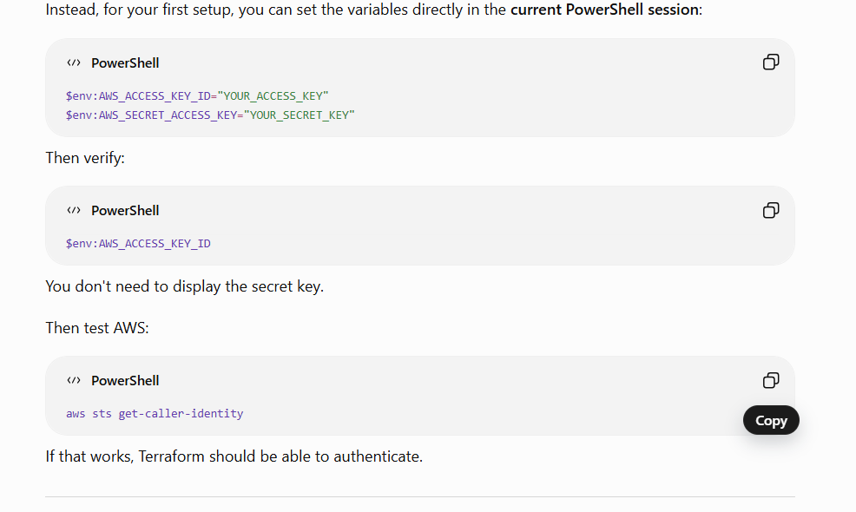
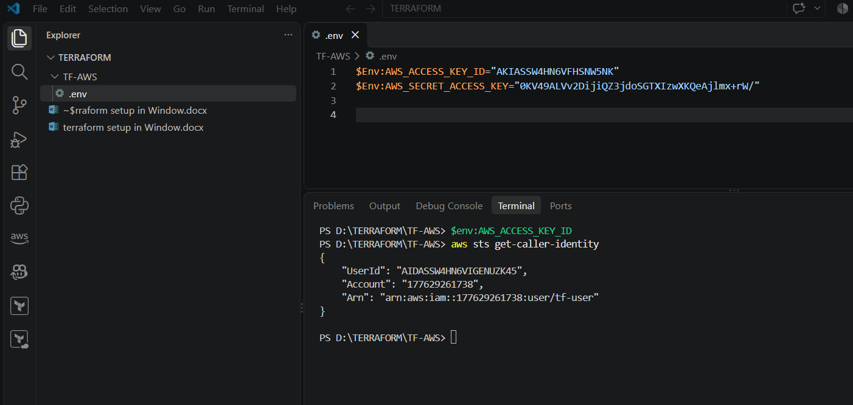
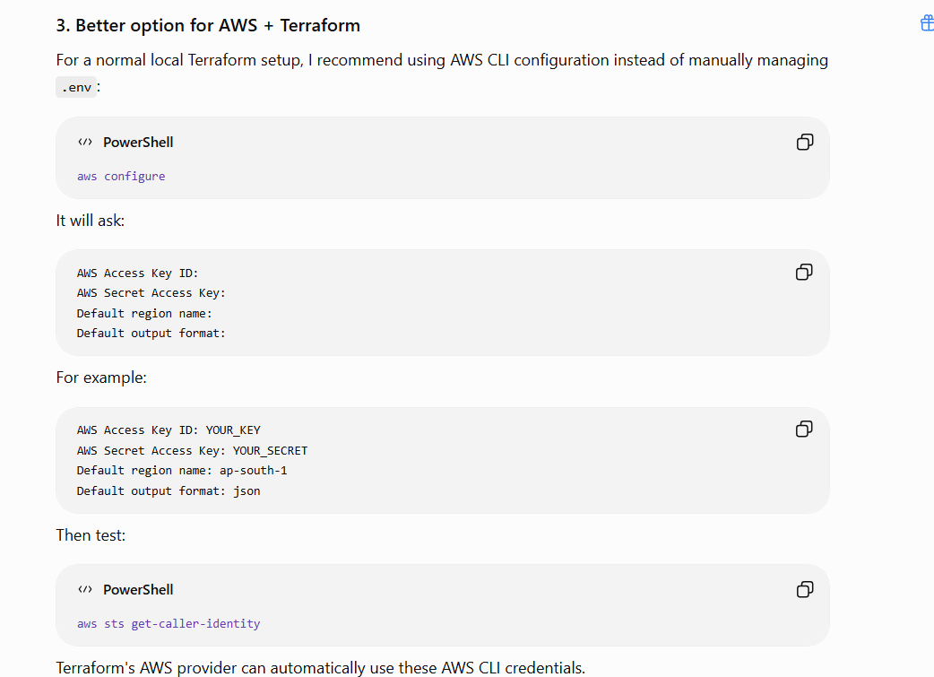
======================creating EC2 instance for 1st time=============================
Path for provide setup code:- hashicorp/aws | Terraform Registry
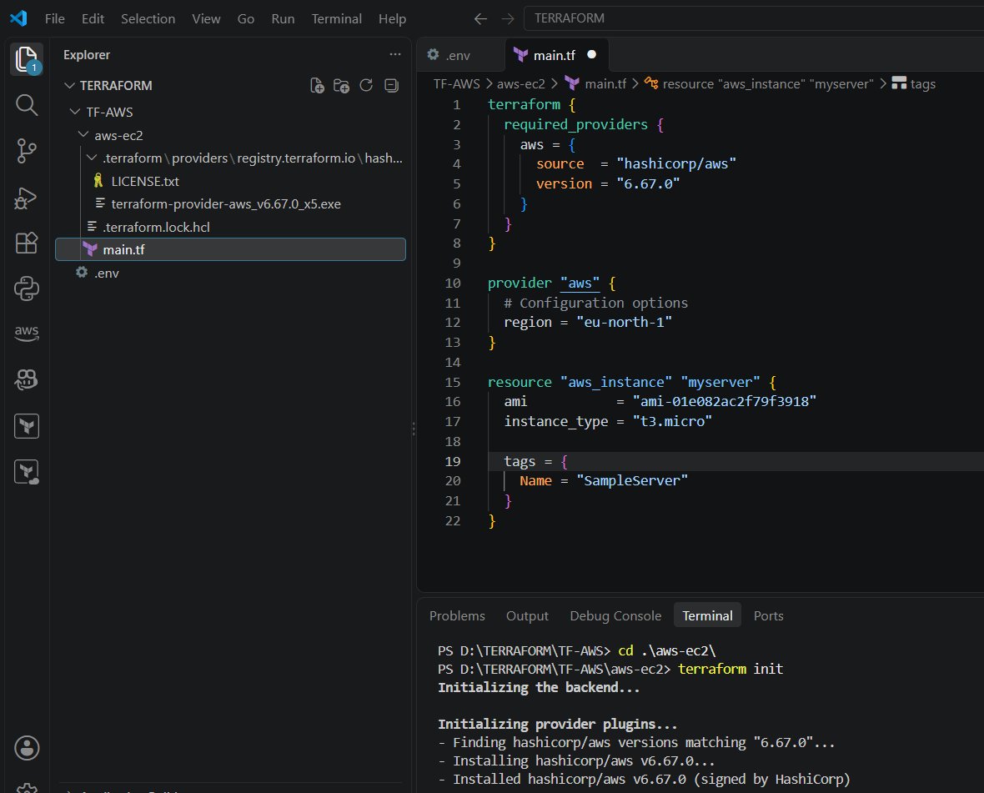
Other 2 files are created automatically to track the changes.

To check the plan what is going to be apply:- terraform plan
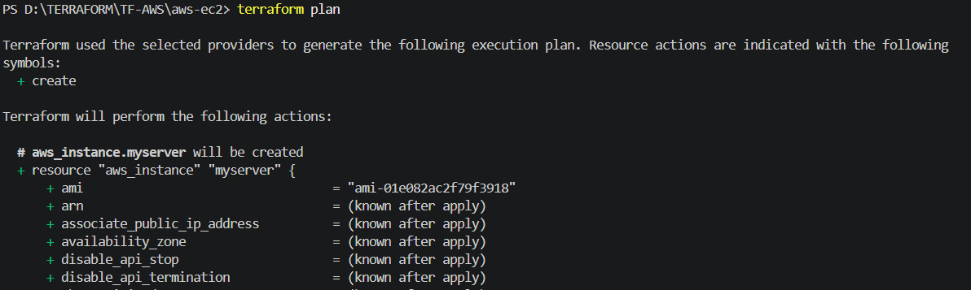
To apply or execute this: - terraform apply
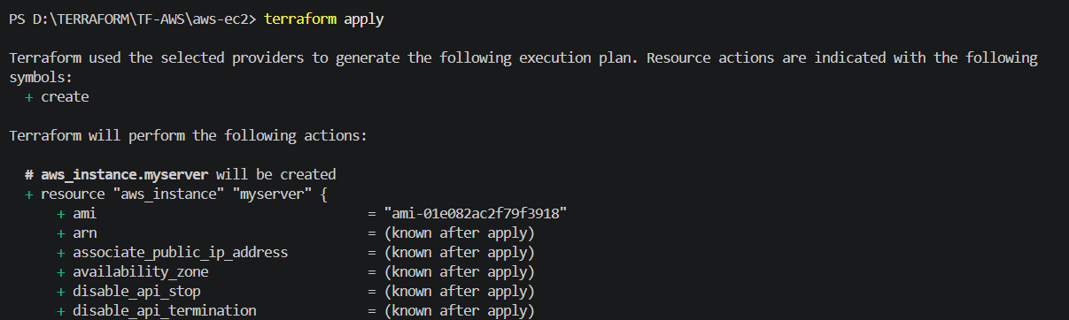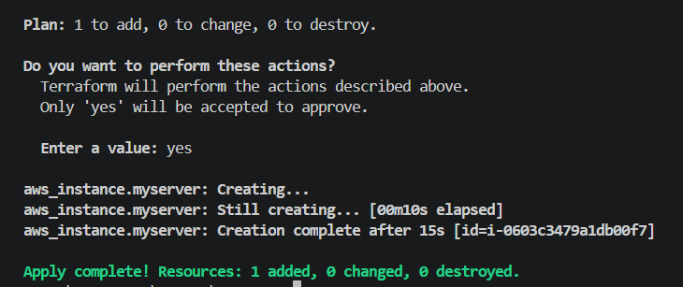

+========================To change the resources=================================+
Suppose I change t3.micro to t3.nano
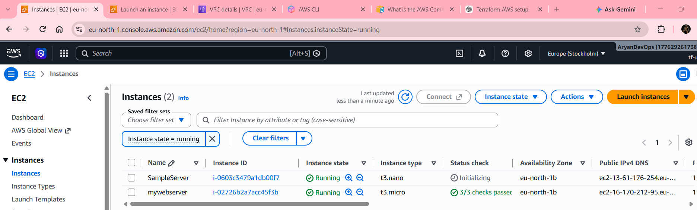
If will change the OS like will replace the instance type & ami :- it replace existing one after destroying
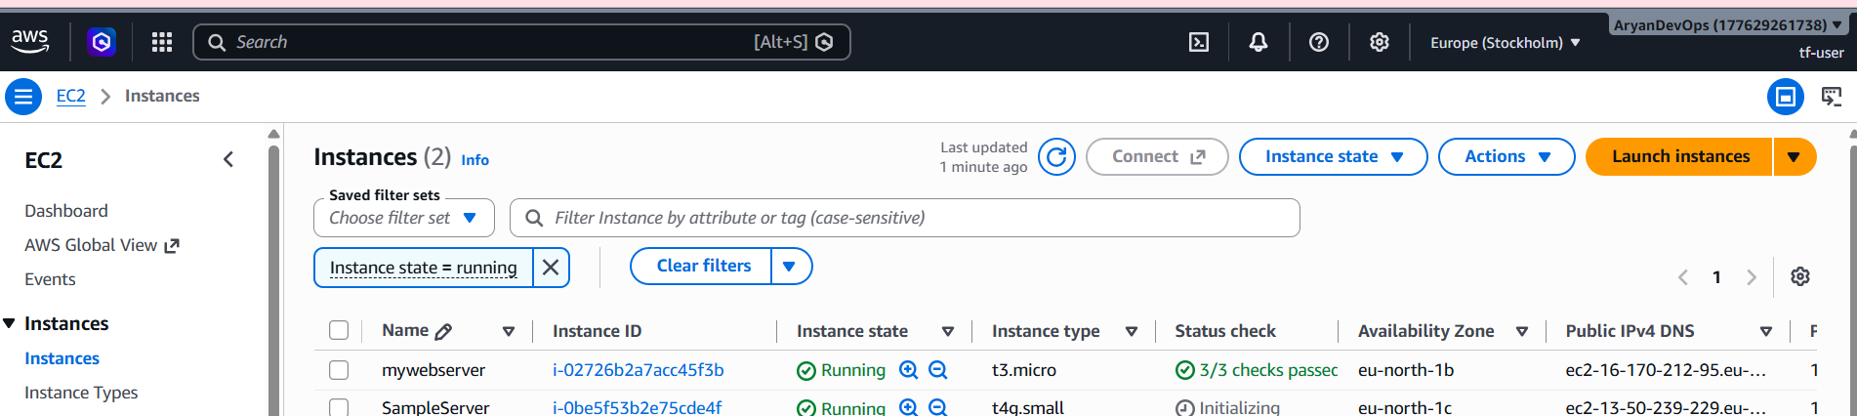

To destroy all infrastructure: - terraform destroy
Only those will be destroyed which is created by using terraform.
To check whether file/code is correct or not: - terraform validate
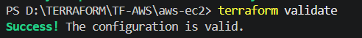
State Management:- state is maintained in a by default created file. {}terraform.tfstate
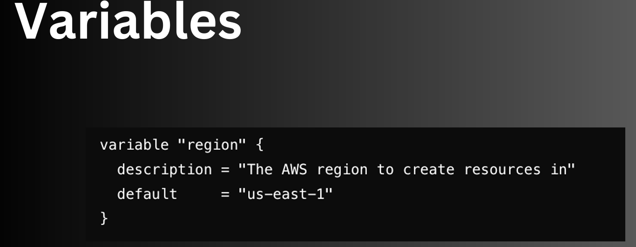
We can use same variable at multiple places and if we change at one place then all the references will be changed.
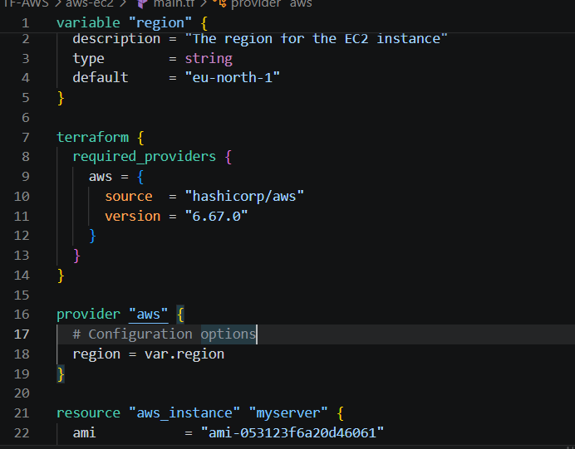
We can create this variable in a separate file.
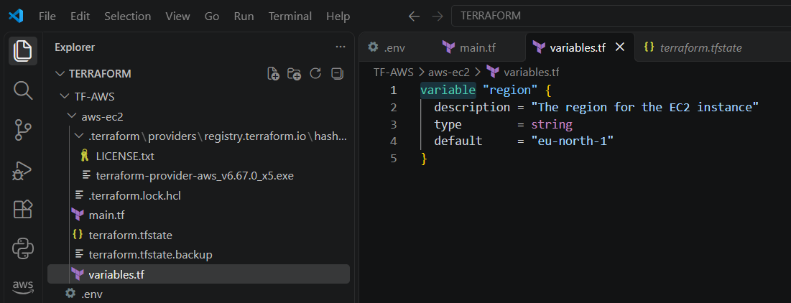
Variable is kept in different file and still it is working.

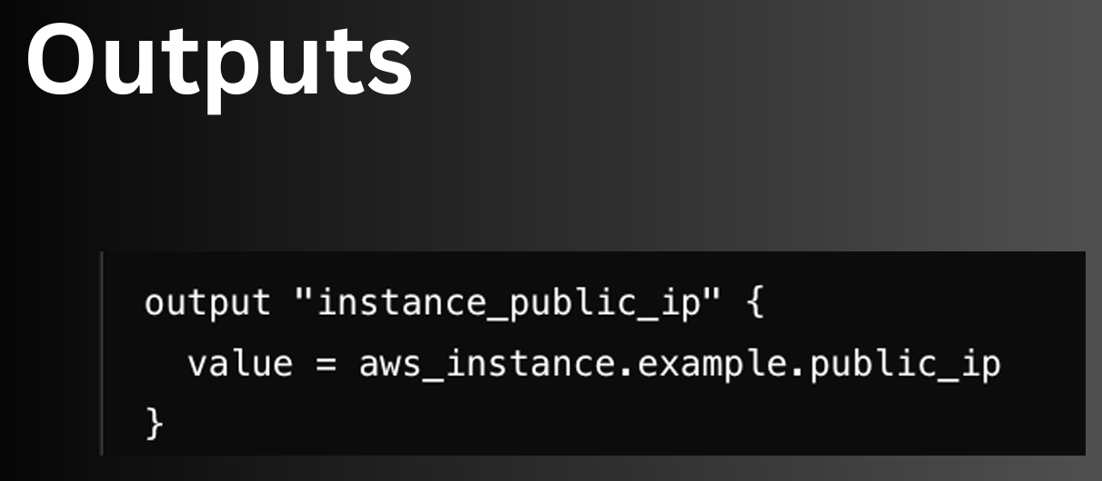
We want information related activity executed on terminal.
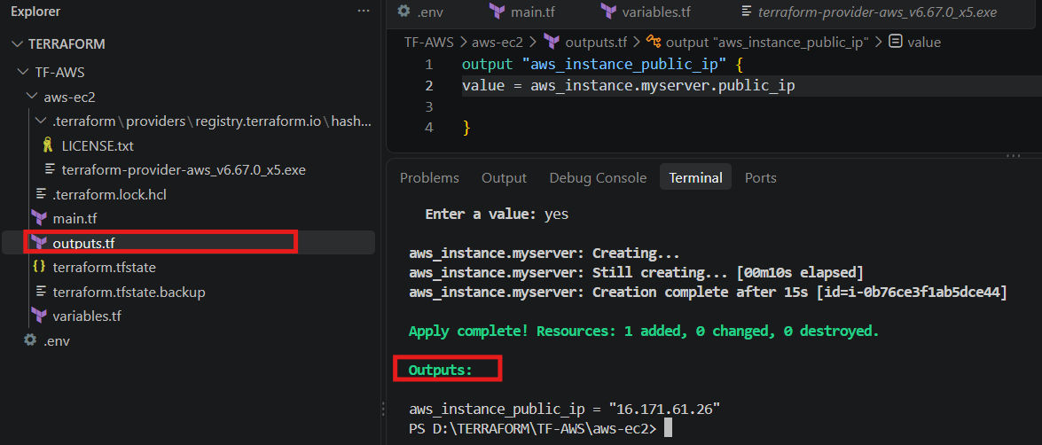

======================********************+++++++++++++++++++++========================
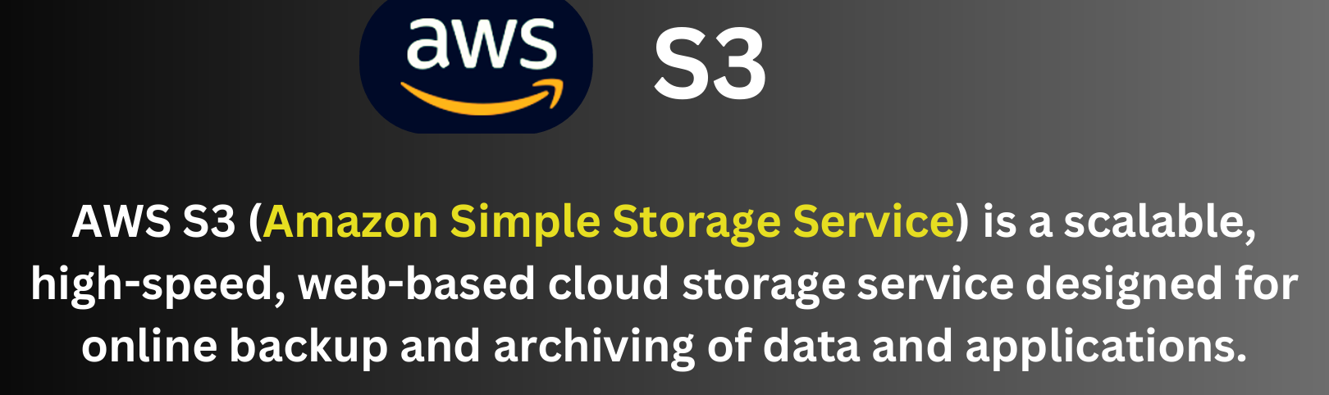
Created s3 bucket and added a file, a unique name required for bucket.
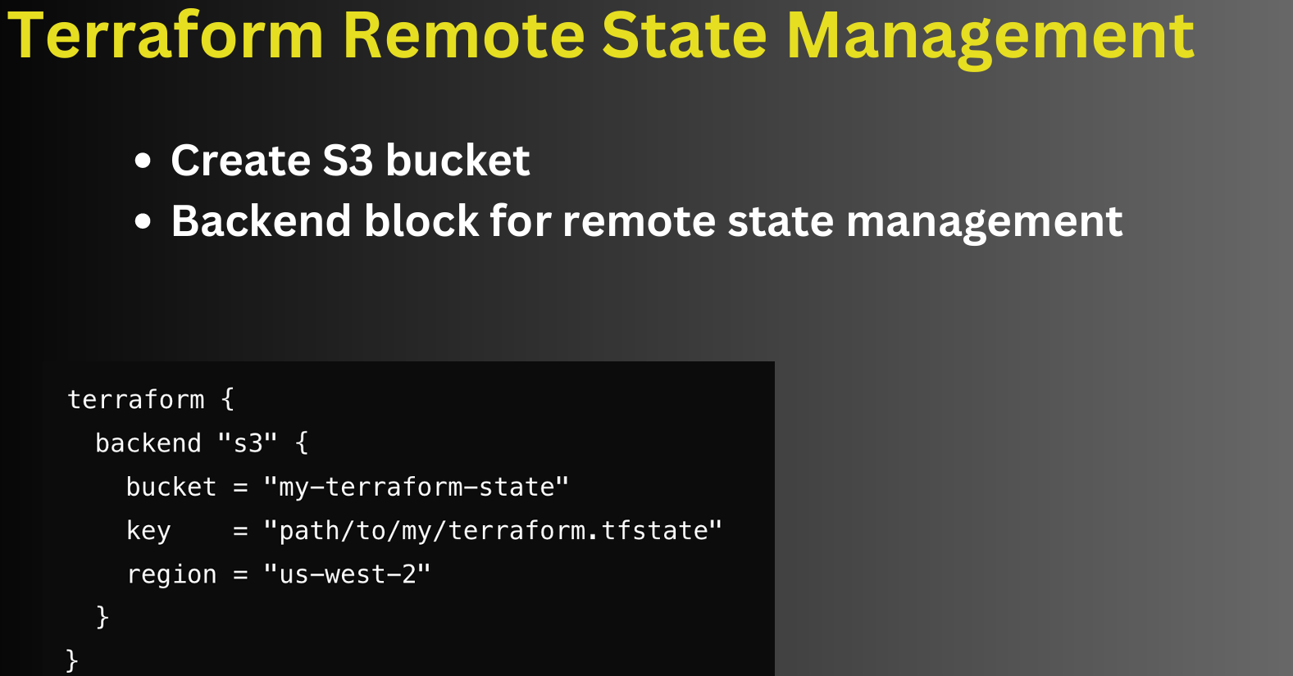
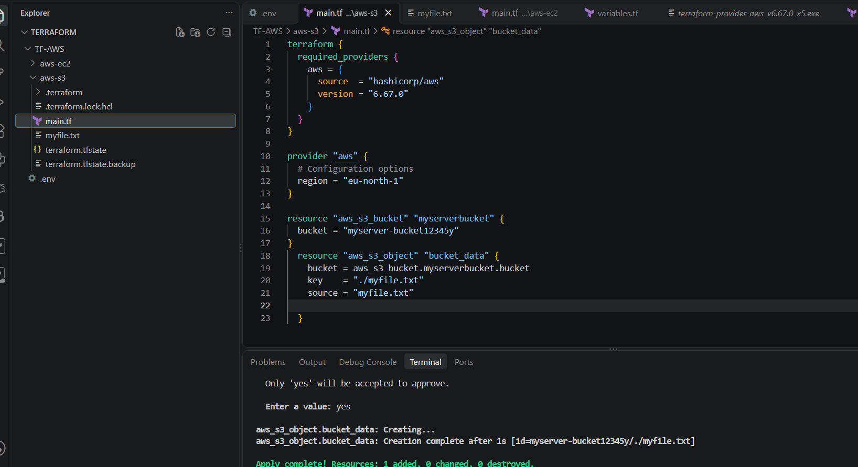


To generate the random data/number….
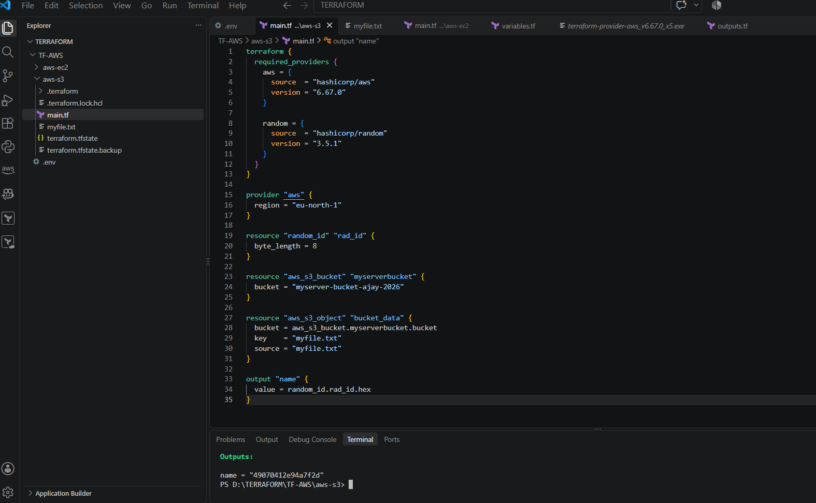

We can use it for unique bucket
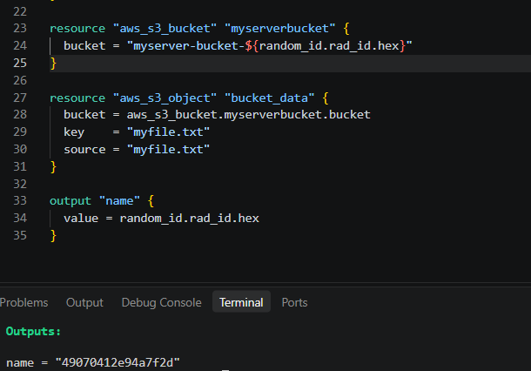
+++++++++++++==++++++++++++++++++++++++++++++++++++++++++++++++++++++++++======++++
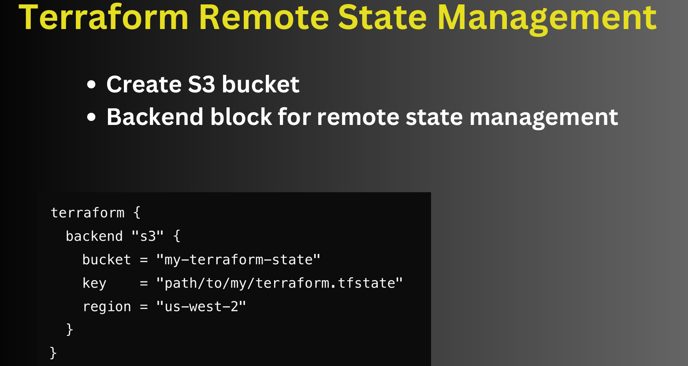

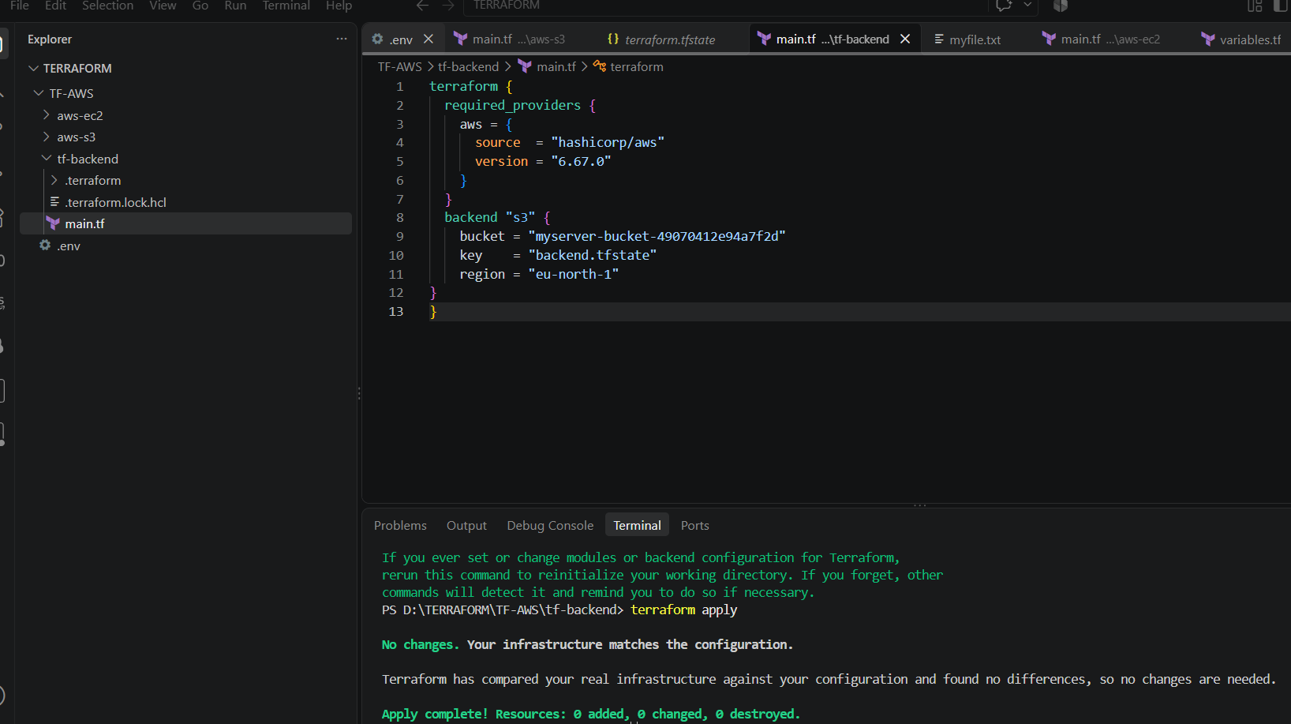
This file kept in S3 bucket so that all team member can access it and is being implemented can be seen by all the team member.
It`s updated whenever we run command locally and when it is kept in SC3 bucket then it can`t be seen locally.
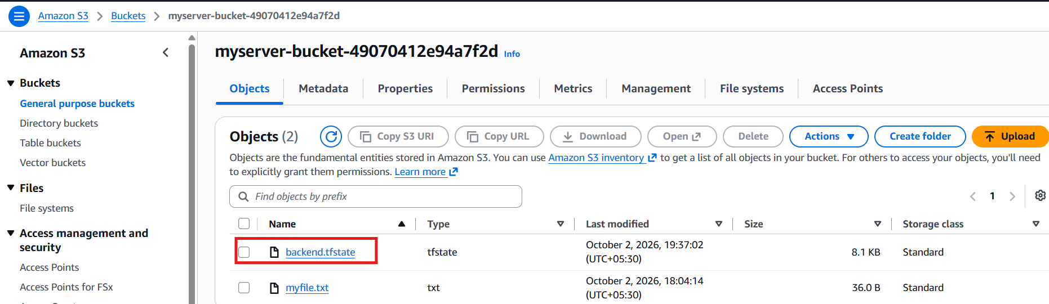
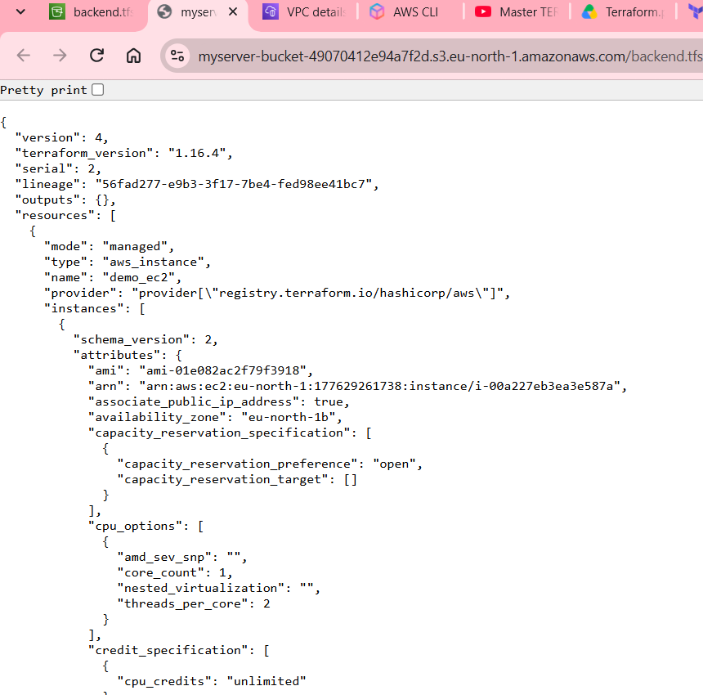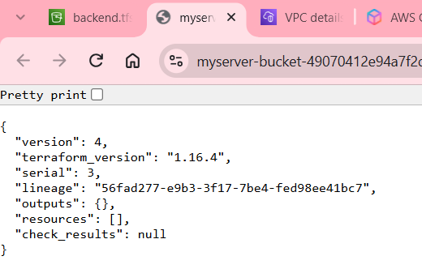
After running instance After destroying

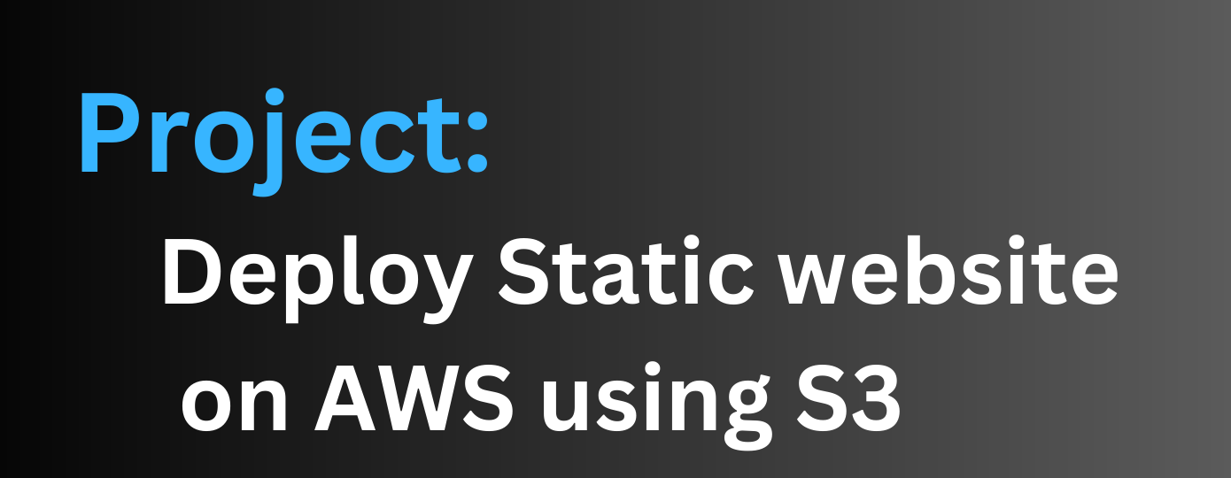
We should divide the task into multiple steps
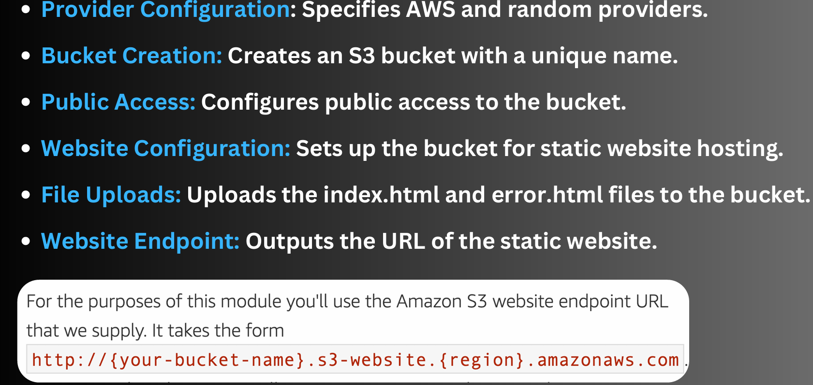
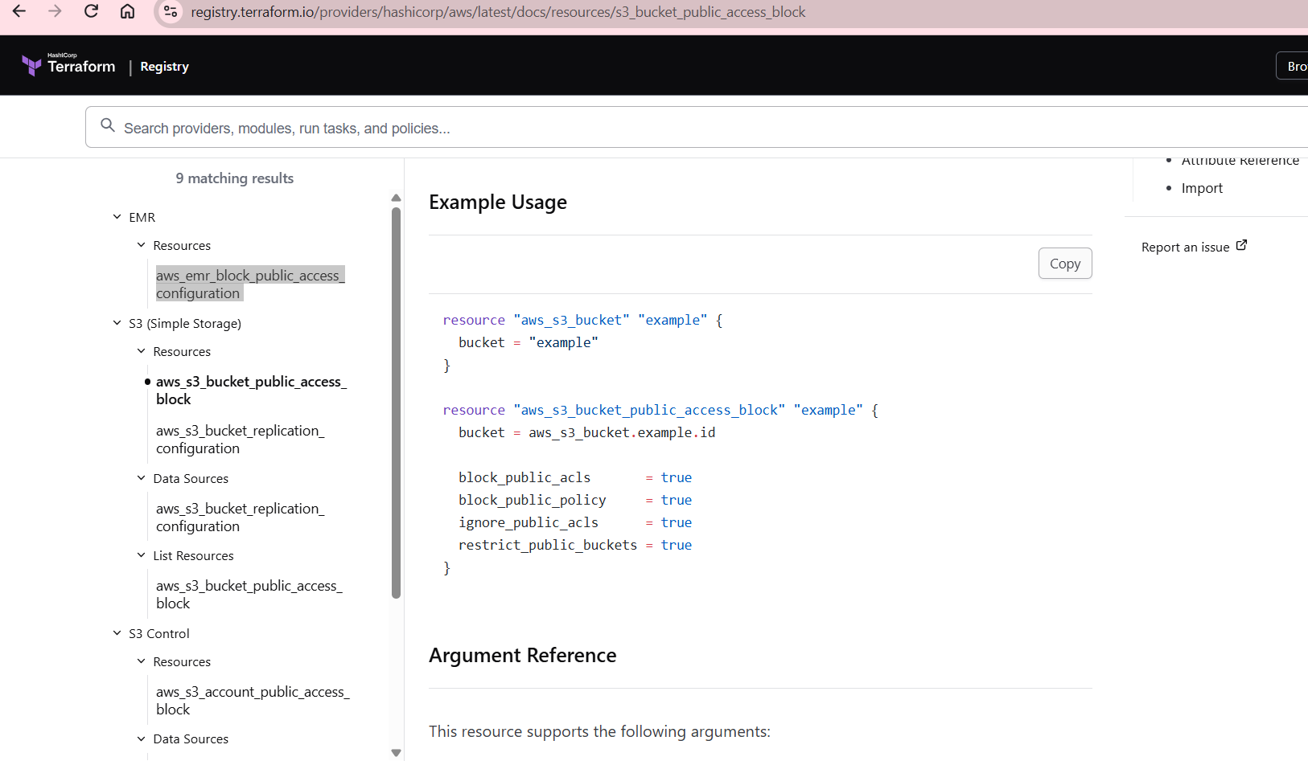
To give public access to sc3.
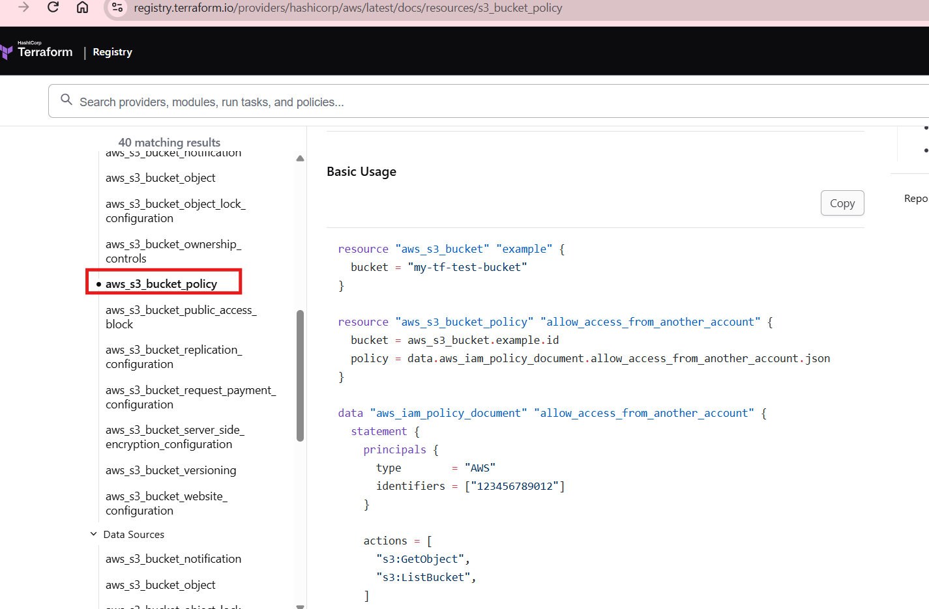
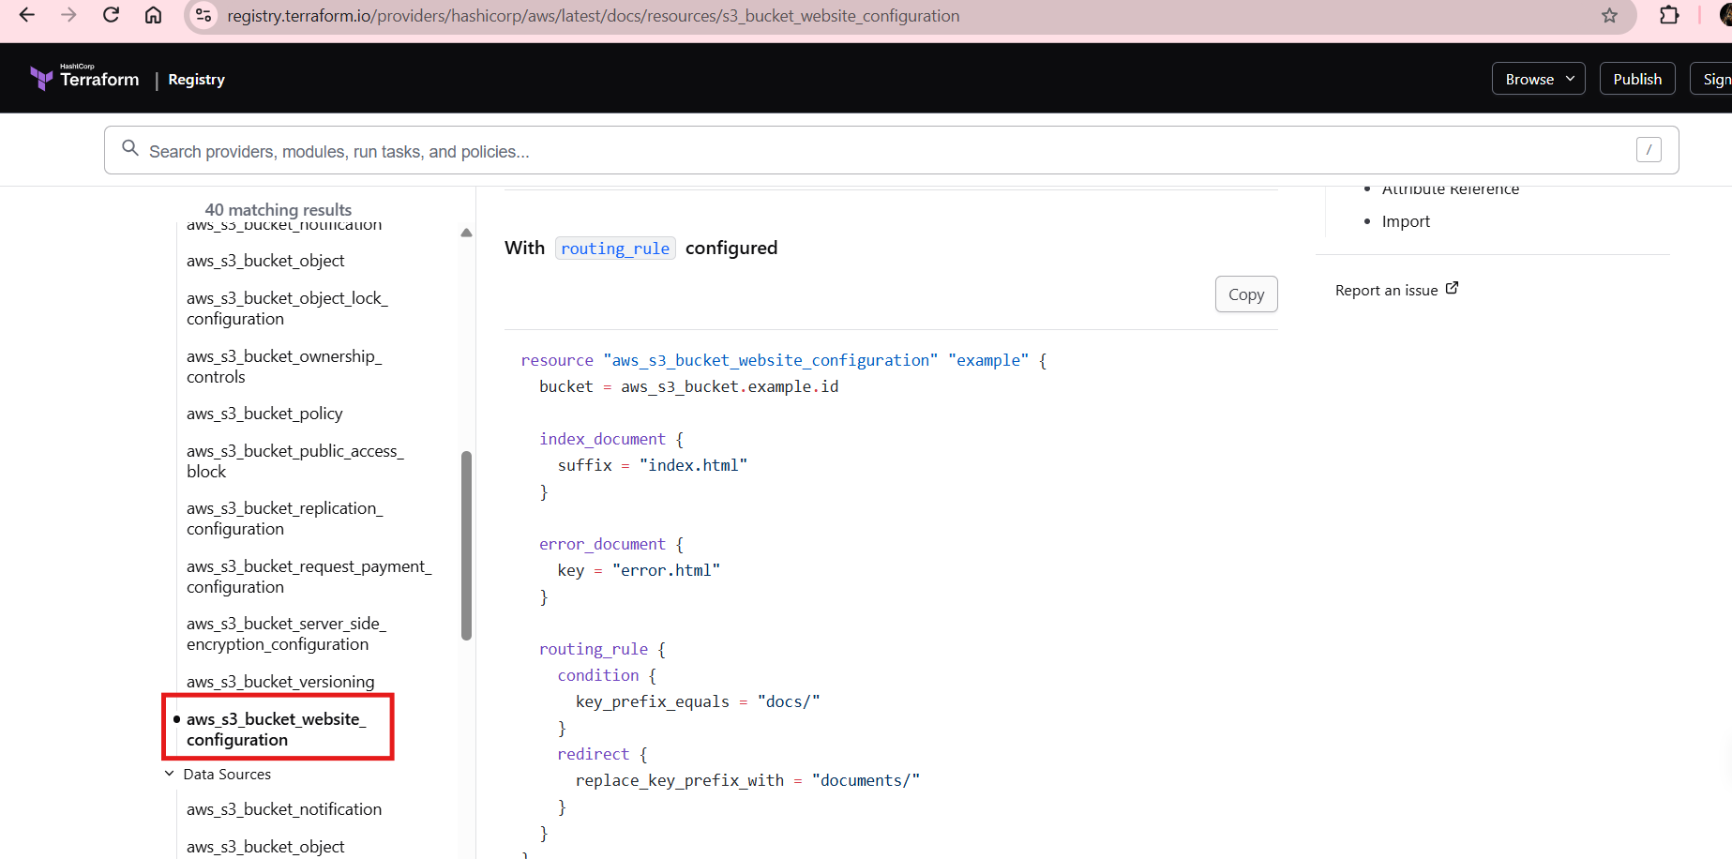
There are multiple steps involved in it
